Compatible chargers

ALIANT STARTER LITHIUM BATTERIES COMPATIBLE CHARGERS AND MAINTAINERS
The charge of a lithium battery generally involves the use of an ad hoc charging system, or of a battery charger designed specifically for the tensions characteristics of the cells and batteries which must be used. Even small differences in operation can cause unpleasant malfunctions and a significant reduction in battery life, and even lead to the bulge and the explosion of the same. The optimization of the charging circuit - thanks to a dedicated firmware - allows the Aliant battery charger CB1210 and CB1203 to ensure a perfect charging curve, a significant reduction in the time charge and the certainty of a full charge in any condition.
Aliant batteries are characterized by very similar voltages corresponding to the traditional lead-acid batteries, but differently from the latter, they are not subject to sulfation. In our laboratory in Imola we have tested several maintainers on the market, in order to assess their compatibility with the Aliant batteries of X and X-P series: for brevity the following table shows the ONLY models which resulted as compatible.
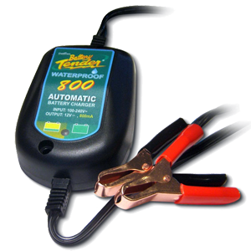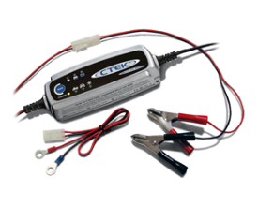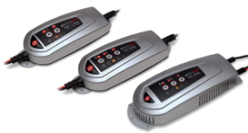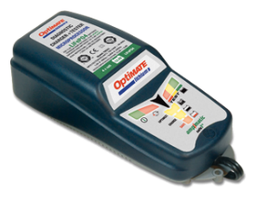
It is strongly recommended to use trickle chargers or mantainers when an infrequent / seldom use can involve long storage periods of the lithium batteries, while connected to the motorcycle electric system.
BRAND | SERIES | MODEL | TENSION | CURRENT | CHARGING TIME OF ALIANT YLP14 BATTERY
BOSCH | C | C3 | 12V | 0.80 A | 10 h
CTEK | XS | XS800* | 12 V | 0.80 A | 10 h
CTEK | XS | XS08* | 12 | 0.80 A | 10 h
CTEK | XS | XS3600* | 12 V | 3.60 A | 3 h
CTEK | XS | Lithium | 12 V | 3.60 A | 3 h
DECA | SM | SM1208* | 12 V | 0.80 A | 10 h
TECMATE | Optimate | 2 | 12 V | 0.80 A | 10 h
TECMATE | Optimate | Lithium 5A | 12 V | Auto 0.4-5A | 4 h
TECMATE | Optimate | Lithium 0.8A | 12 V | Auto 0.8 A | 10 h
TECMATE | Optimate | Lithium QUAD | 12 V | 4 x 0.8 A | 10 h
TECMATE | Accumate | Compact | 12V | 0.60 A | 10 h
DELTRAN | Battery Tender | Waterproof 400 Intl. | 12 V | 0.40 A | 18 h
DELTRAN | Battery Tender | Waterproof 800 Intl. | 12 V | 0.80 A | 9 h
DELTRAN | Battery Tender | Intl. 1.25 | 12 V | 1.25 A | 6 h
DELTRAN | Battery Tender | Junior 0.75 | 12 V | 0.75 A | 10 h
DELTRAN | Battery Tender | Plus 1.25* | 12 V | 1.25 A | 6 h
DELTRAN | Battery Tender | GEL 1.25* | 12 V | 1.25 A | 6 h
DELTRAN | Battery Tender | International 5* | 12 V | 5.00 A | 1.5 h
DELTRAN | Battery Tender | Waterproof 5 Plus* | 12 V | 5.00 A | 1.5 h
ELECTROMEM | HF | HF100 1A | 12 V | 1.00 A | 8 h
PULSETECH | XC | XC100P | 12 V | 2.50 A | 4 h
PULSETECH | XC | PRO12RP | 12 V | 0.75 A | 11 h
ALIANT | CB | CB1203** | 12 V | 3.00 A | 2 h

* The models marked with an asterisk are compatible for charger use only and you should never leave them unattended and connected for indefinite periods of time, as the retention curve considerably reduces the life of lithium batteries. It is better not to use these chargers because some automatic program of desulfation and low temp charging can start, damaging the battery and causing possible dangerous situations (explosion, fire, inflation) no warranty will be applied in case of use of these chargers.
**The recommended Aliant charger for motorcycle starter batteries are the CB1203 and CB1203+KIT ones. The use of CB1210 and CB1210+KIT chargers is suitable ONLY for professional customers, and it is suggested only when really quick charging is needed.
We recommend using the maintainer when the motorcycle is not often used or the high current consumption is high even when the engine is off, to prevent complete draining from the lithium battery during winter storage or during other periods of rest. In general, the use of compatible maintainers is useful to increase the battery life and preserve it properly during downtimes.
Remember, it is always MANDATORY to attend and monitor the charging of lithium batteries and do not leave batteries in charge without being supervised. Read carefully the product manual before use and recharge the battery.
Remember, it is always FORBIDDEN to charge lithium batteries together or in same room of lead acid batteries. Lithium batteries shall be charged ONLY in dedicated room, supervised by expert and professional people constantly during charge. The charge room shall be equipped with proper extinguishing devices.
The models not mentioned in this list are NOT COMPATIBLE and THEREFORE SHALL NOT BE USED in any case, if in doubt please contact us for further verification.

